**Stock Order Entry Template**

* OIS100/A - Enter Customer #, If blank on Data Sheet, allow Customer’s Order Type to default to value brought in, and Request Date to default to Today’s Date

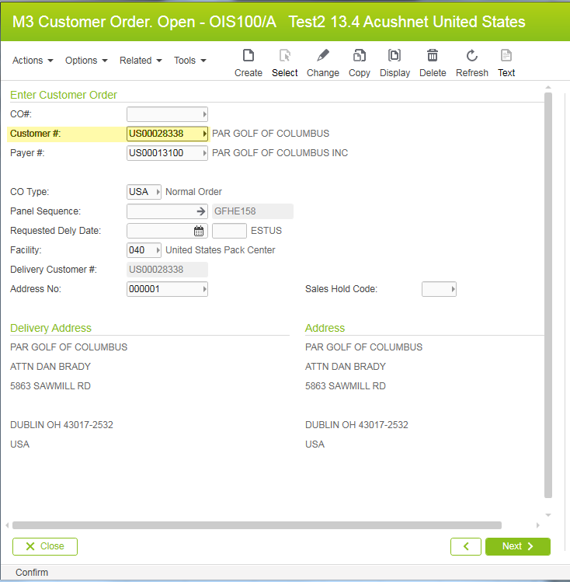

* OIS100/G - Add Customer PO indicated on Data Sheet: NDNC /C18

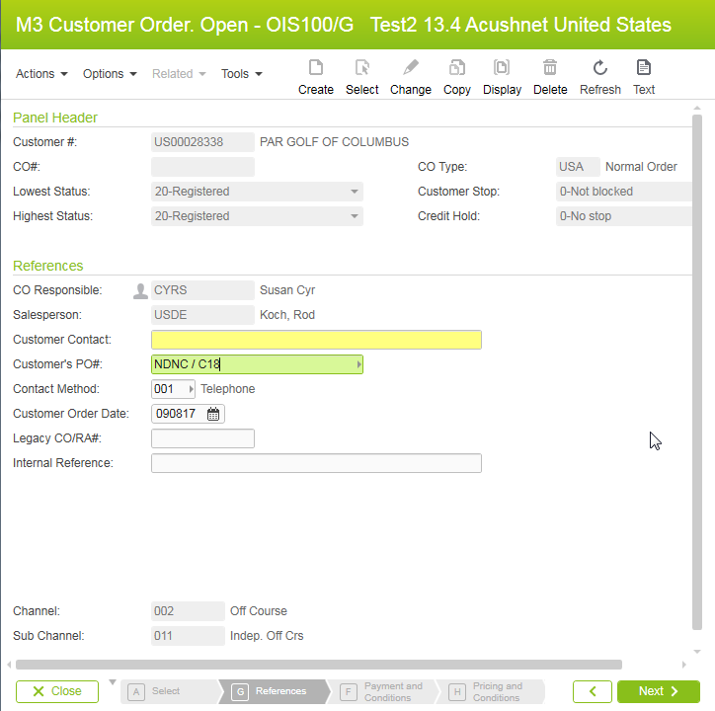

* **OIS100/F - Update Tag field, Delivery Method, Delivery Term if shown on Data Sheet or allow default value to remain**

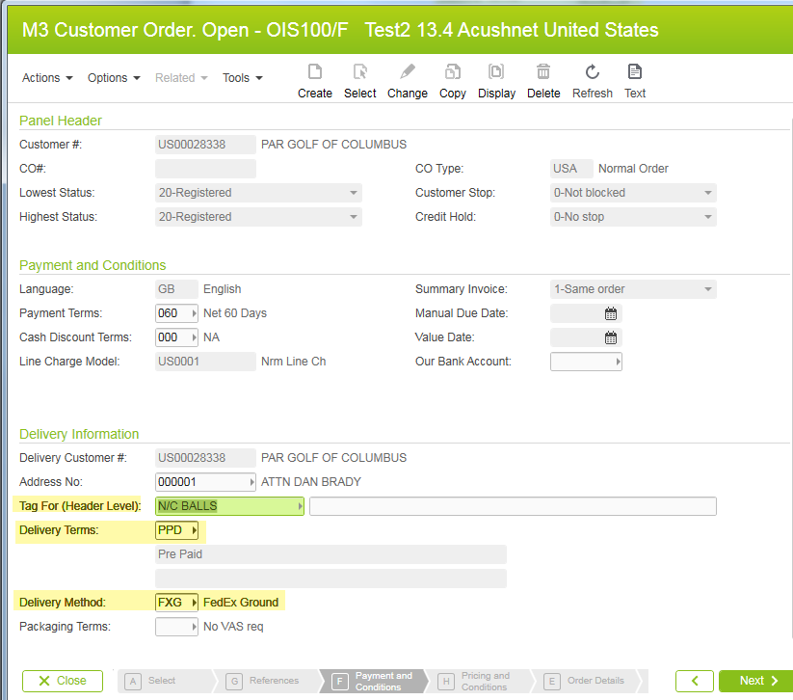

* **OIS100/H – No value or field updates required, select Next or Enter**

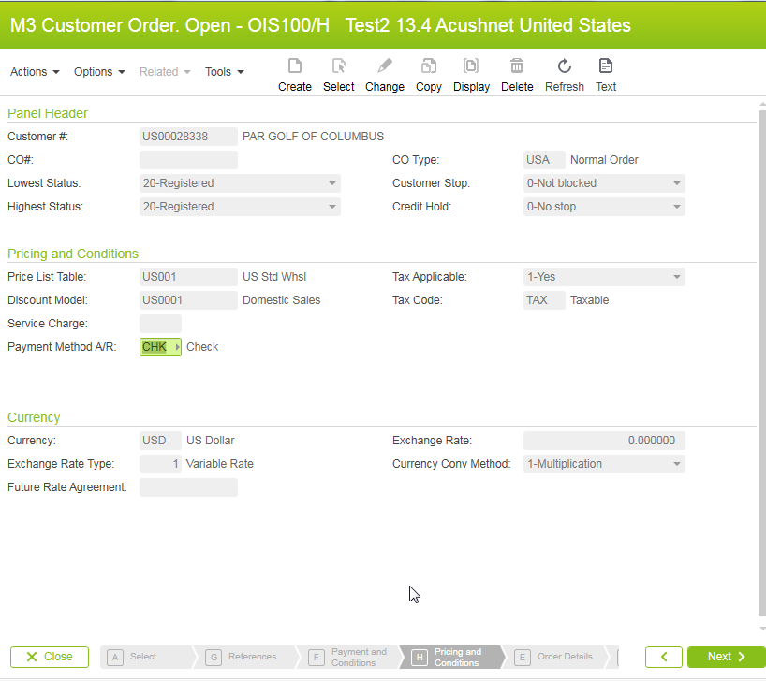

* **OIS100/G – Priority Value defaults unless specified in Data Sheet**

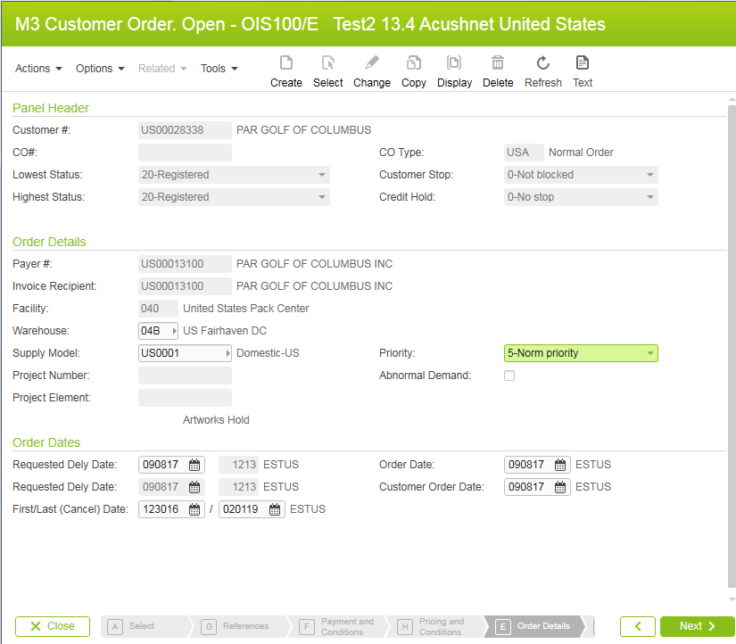

* **OIS102/H - No value or field updates required, select Next or Enter**

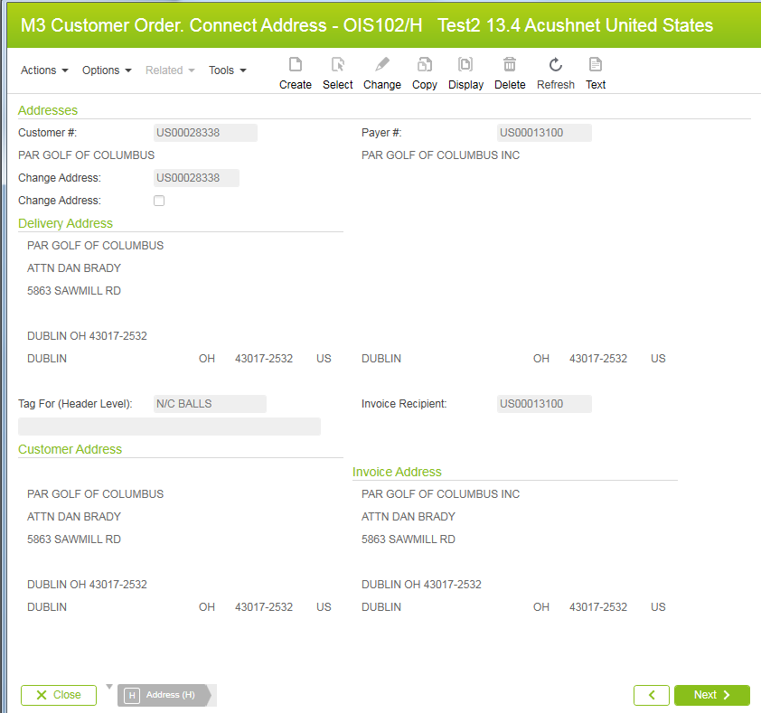

* **OIS101/B – Enter Order line details according to Data Sheet** 
  + **Item or Items**
  + **Quantity**
  + **Promotion Code**
  + **Transaction Reason Code**
  + **Blanket Agreement**

**Example of Promotion Code with Transaction Reason Code:**

* **Enter Order line, Qty, Promo code, Transaction Reason at same time**

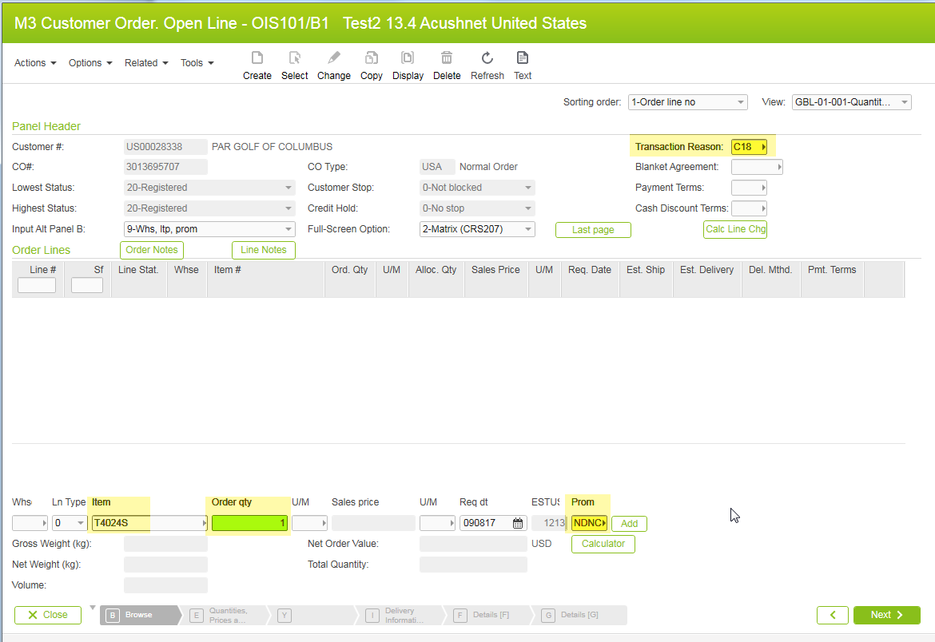

* **Discounts show in Promo Disc as shown in Screenshot**

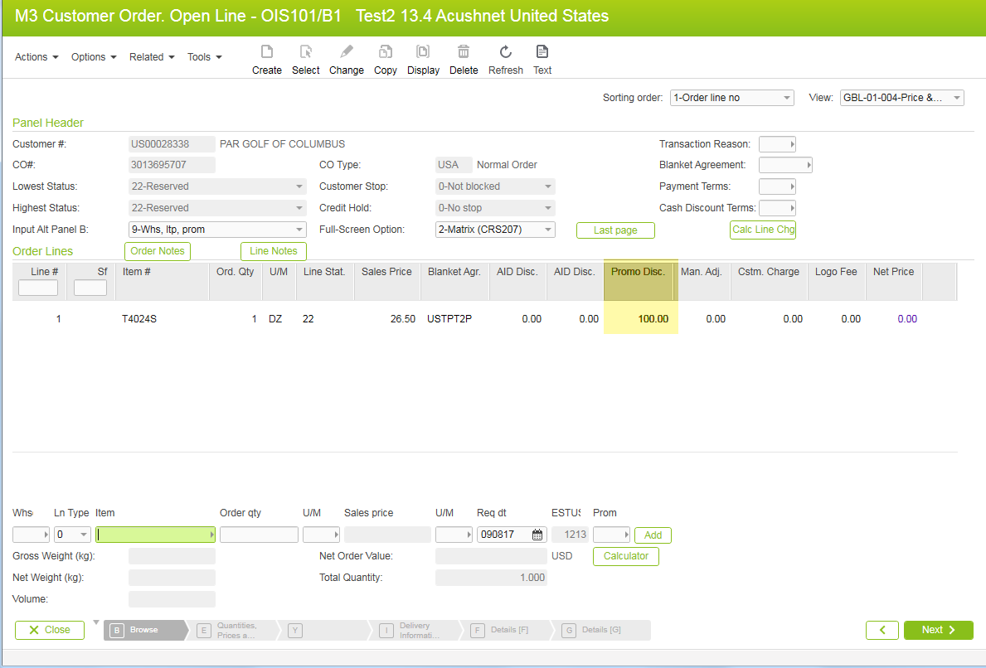

**Example of Manually Applied Blanket Agreement with Transaction Reason Code:**

* **Enter order lines then highlight all order lines to apply Blanket Agreement UST8PUP manually**

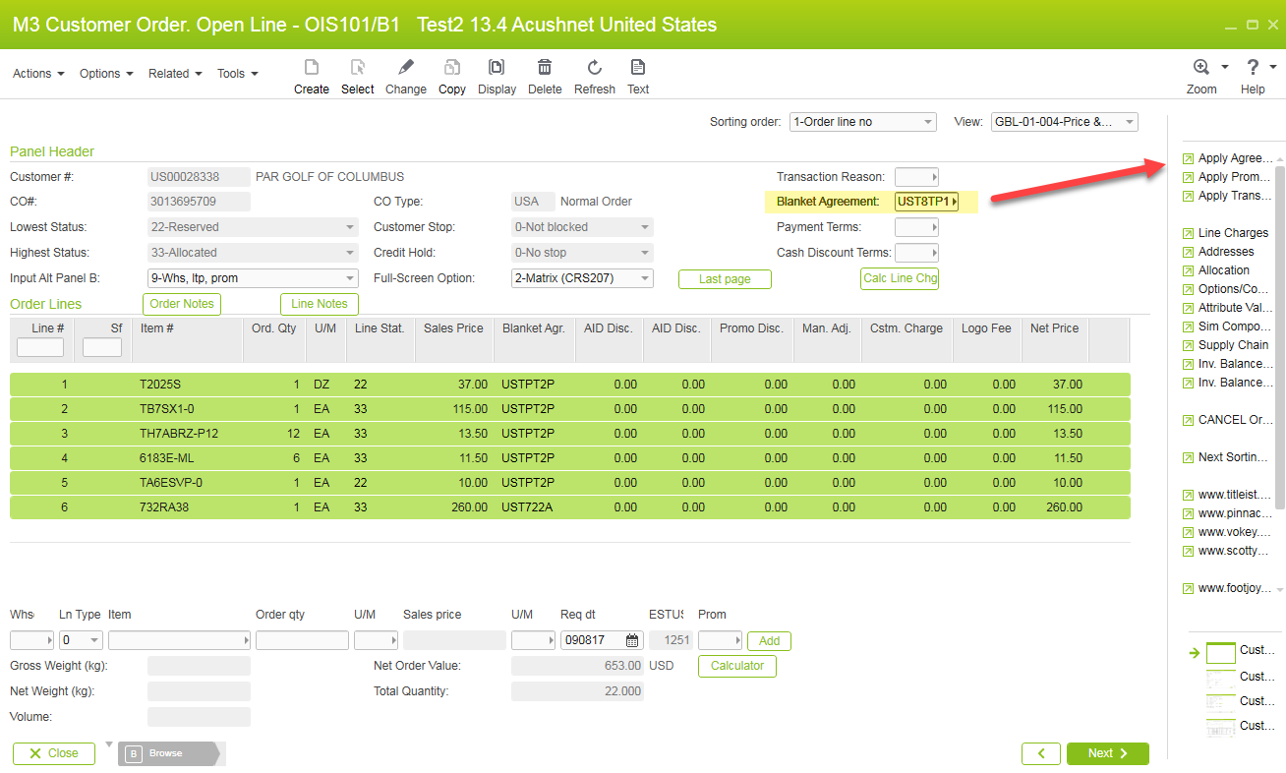

* **Discounts show in AID Discount 1 as shown in Screenshot**

